**NAME:B. GNANESWAR REDDY**

**REG.NO.: 192111448**

**CODE: CSA1366**

**EXPERIMENT: 8**

**AIM:** To design Turing machine to perform subtraction

W=aaa-aa

**PROCEDURE:**

1. Select six states and consider one as initial and another as final state.
2. Join the states using edges with directioons
3. Select the edges as INPUT and OUTPUT as a or b or C
4. Give the input and start the simulation

**DESIGN AND OUTPUT:**

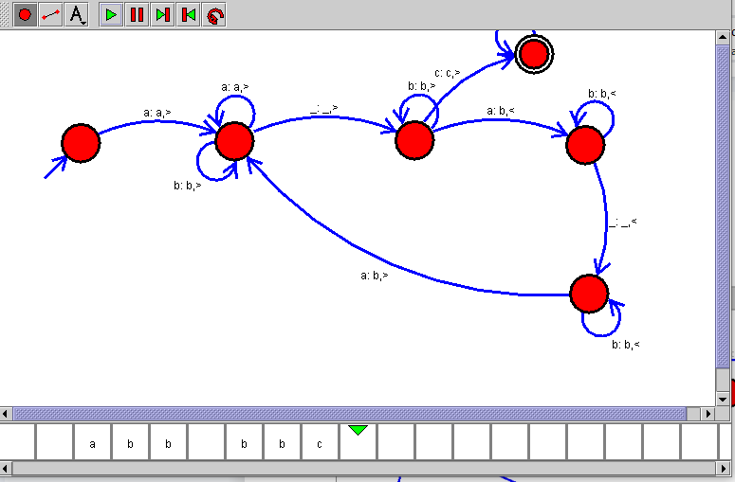

**RESULT:**

Therefore the designing of turing machine for the given input has been successfully created and stimulated.